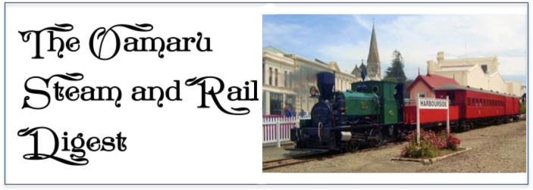

June 2018

**A Plethora of Projects**

With CW 57 almost complete - except for an upcoming excavator installation - and temperatures becoming cooler, the workshop team has tackled a number of projects on the to-do list, working in smaller groups.

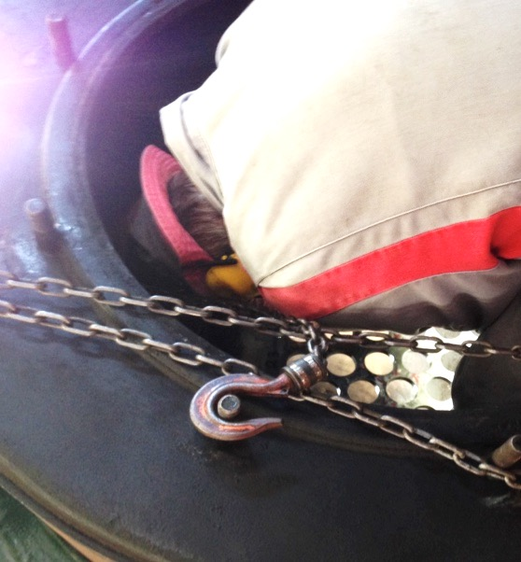

**Steam loco B10**’s front tube plate continues to receive attention prior to refitting her boiler tubes. A pressure vessel certified welder has repaired four small imperfections in the plate surface. These welds have since been machined flat and the four adjacent holes re-machined to ensure a snug fit for the tubes. It is hoped that the loco will be running again before the summer season.

**Passenger car A 1514**, which over recent seasons has been our ‘second carriage’ on the train during busy times, is receiving overhead luggage rails and nets inside. Following a review of the exterior, several sections of tongue and groove cladding have been neatly replaced on the outside.

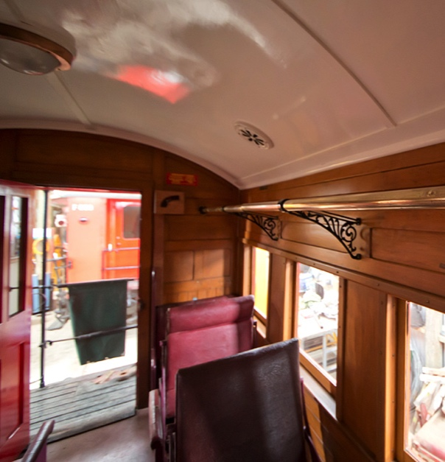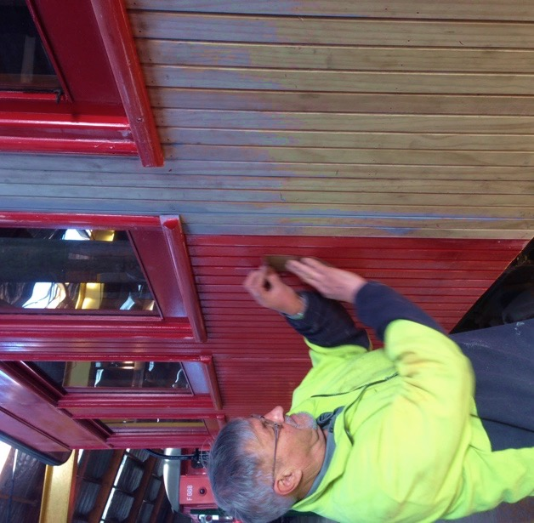

Work has begun with the overhaul of our **Yb ballast wagon** recently acquired from the Ocean Beach Railway in Dunedin. No ‘garage queen’ this, the hopper body has received several coats of rustproofing and paint after being stored outside for many decades in salty air. The bottom door is almost ready for fitting, one of the buffers has been removed for refurbishment, and a start has been made on disassembling brake rigging for cleaning and painting. The wagon has a wheel bearing that needs replacement, so it will be lifted off its wheel sets and flipped over to give easier access for these tasks.

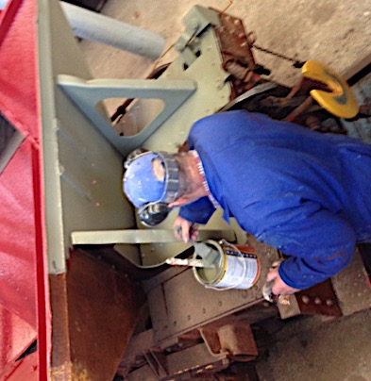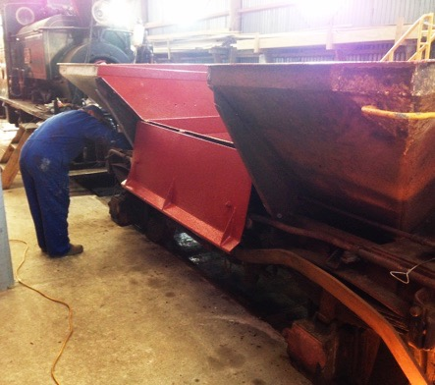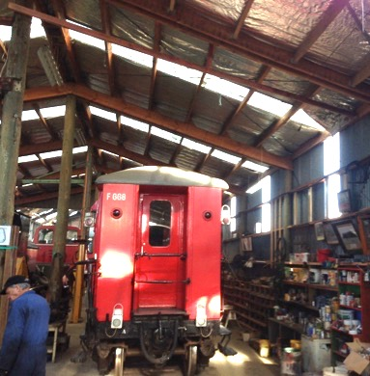

In the workshop building, additional clear plastic **skylights** have been added to the western wall to match those installed on the seaward side last year. These additional sources of natural light improve visibility, making the workshop a safer and more pleasant environment in all weathers.

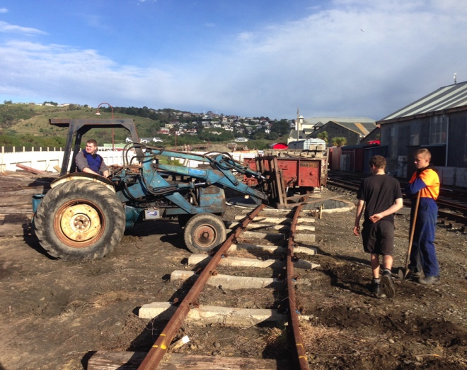Beyond the wagon turntable, rails have sprouted in the direction of Oamaru Creek. This will provide **additional storage** in the compound for rolling vehicles and parts. Despite the weight and length of rails and sleepers, it’s amazing what can be levered into place by a few volunteers with crowbars, chains and an occasional prod from the tractor.

Here, one of our trained experts is about to demonstrate our self-burying tractor.

**Come along for a Cuppa: Friday 18th of June at The Brydone**

Everyone is welcome to attend our informal monthly coffee mornings. Come along for a chat over a cuppa at The Brydone Hotel on the 18th of June at 10:15am. As always, please RSVP to Anthea by the evening of the 16th so that we can give them an idea of our numbers (anthea.oamaru@gmail.com)